**Diesel-generators () Theory Exam 2009**

1. (2pts) What is a genset?

**Answer:**

A genset is short for a prime mover and a generator, where the prime mover typically in this course is a diesel engine.

1. (4pts) What type of electric machine is the most commonly used to generate electric power? Explain the basic components and main principles for converting mechanical energy into electric energy for this generator type. Explain what “brushless excitation” means.

**Answer:**

(1pts) A synchronous generator is most often used as generator of electric power.

(2pts) For this type of generator, a fixed magnetic field is set up in the rotor of the generator by use of a DC excitation current, typically suing slip rings and brushes. The magnetic field will then rotate with the shaft that is driven by the prime mover. In the stator the generator there are 3-phase windings in which the rotating magnetic field induces a voltage by Faraday’s law and 3-phase currents when the stator windings are connected to a load.

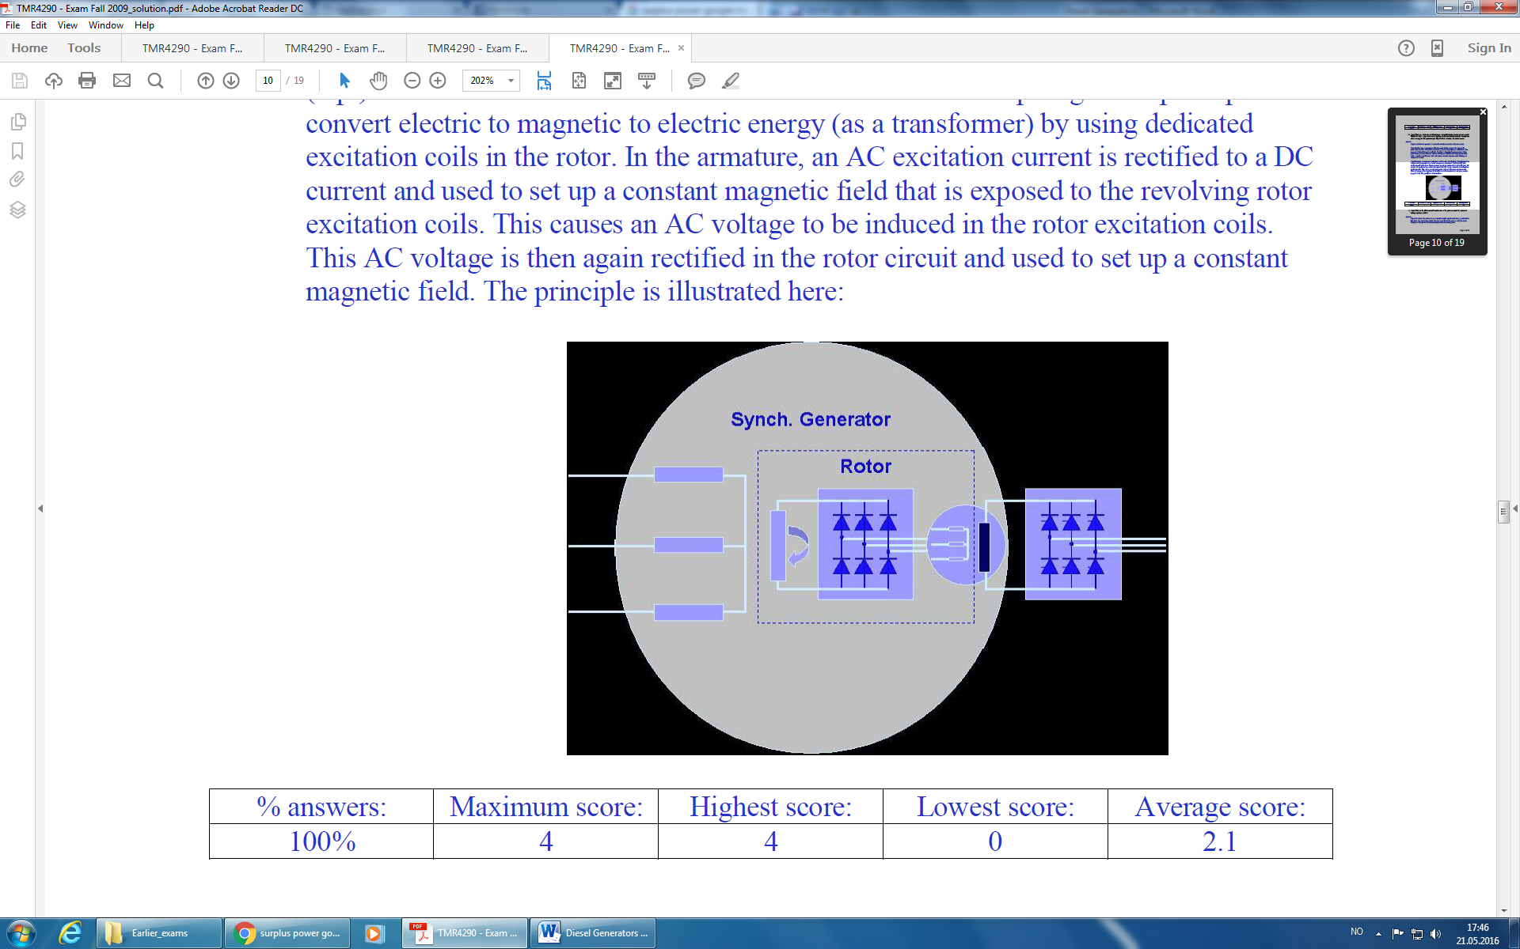 (1pts) Brushless excitation is a method to avoid brushes and slip rings. The principle is to convert electric to magnetic to electric energy (as a transformer) by using dedicated excitation coils in the rotor. In the armature, an AC excitation current is rectified to a DC current and used to set up a constant magnetic field that is exposed to the revolving rotor excitation coils. This causes an AC voltage to be induced in the rotor excitation coils. This AC voltage is then again rectified in the rotor circuit and used to set up a constant magnetic field. The principle is illustrated here:

1. (4pts) What are the direct and indirect functions of the governor and of the automatic voltage regulator (AVR)?

**Answer:**

(2pts) Governor:

* Direct function: To control the engine speed to reference speed.
* Indirect function: To control the electric frequency to the reference frequency and to ensure sharing of active power between several parallel connected gensets.

(2pts) Automatic Voltage Regulator (AVR):

* Direct function: To control the generator terminal voltage to reference voltage.
* Indirect function: To ensure sharing of reactive power between several parallel connected gensets.

1. (2pts) What are the two most commonly used principles for sharing of active power?

**Answer:**

(2pts) The two most commonly used principles are: Sharing by speed droop control and Isochronous sharing

1. (2pts) In what configuration is it possible to have one “swing machine” that takes up the entire load variation in the power network, while all the other connected generators supply fixed active power?

**Answer:**

(2pts) Of several parallel connected gensets, if one machine is connected in isochronous mode and all others are connected in speed droop mode, then the isochronous genset will ensure the frequency is held fixed on the reference frequency. All other gensets will then deliver fixed power at that frequency according to their individual droop curves. The isochronous genset will become the “swing machine” that takes up the remaining power load variations in the power plant.

1. (9 pts) Two 3-phase, 60 Hz, Y-connected gensets of equal rating 2.1 MVA, 690 V (rms, line-to-line), are connected to a common bus as seen in the figure below. Both generators have a per-phase synchronous impedance of *Zs* = 0.4+j5 Ω. They deliver power to a 3-phase balanced load of 3.3 MVA at power factor 0.8 lagging.

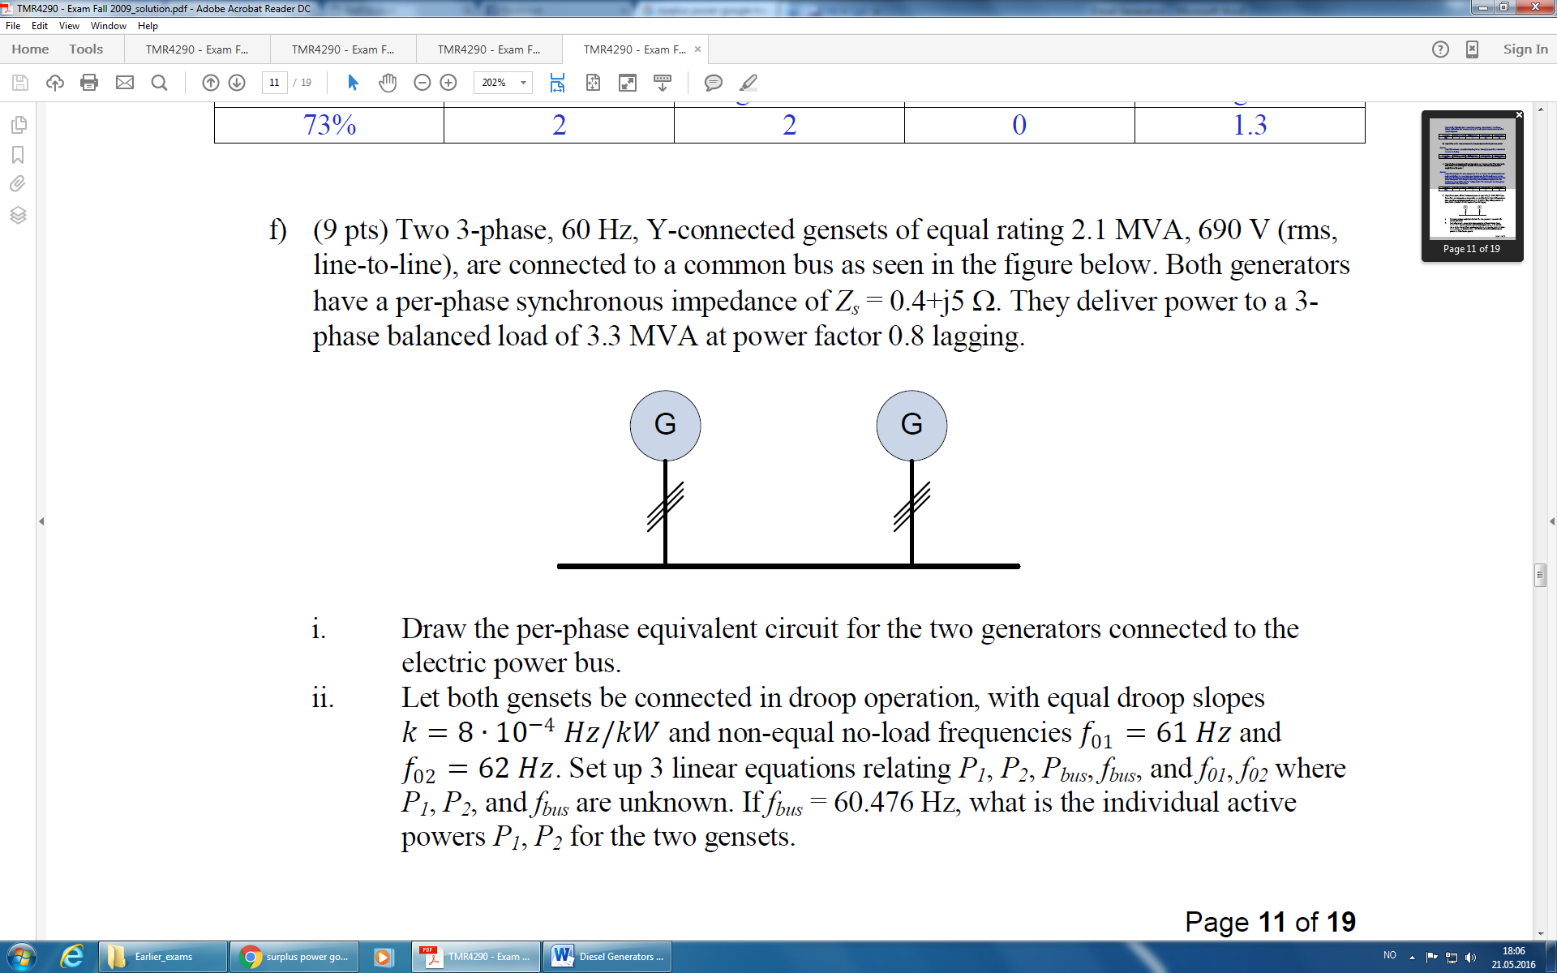

* 1. Draw the per-phase equivalent circuit for the two generators connected to the electric power bus.

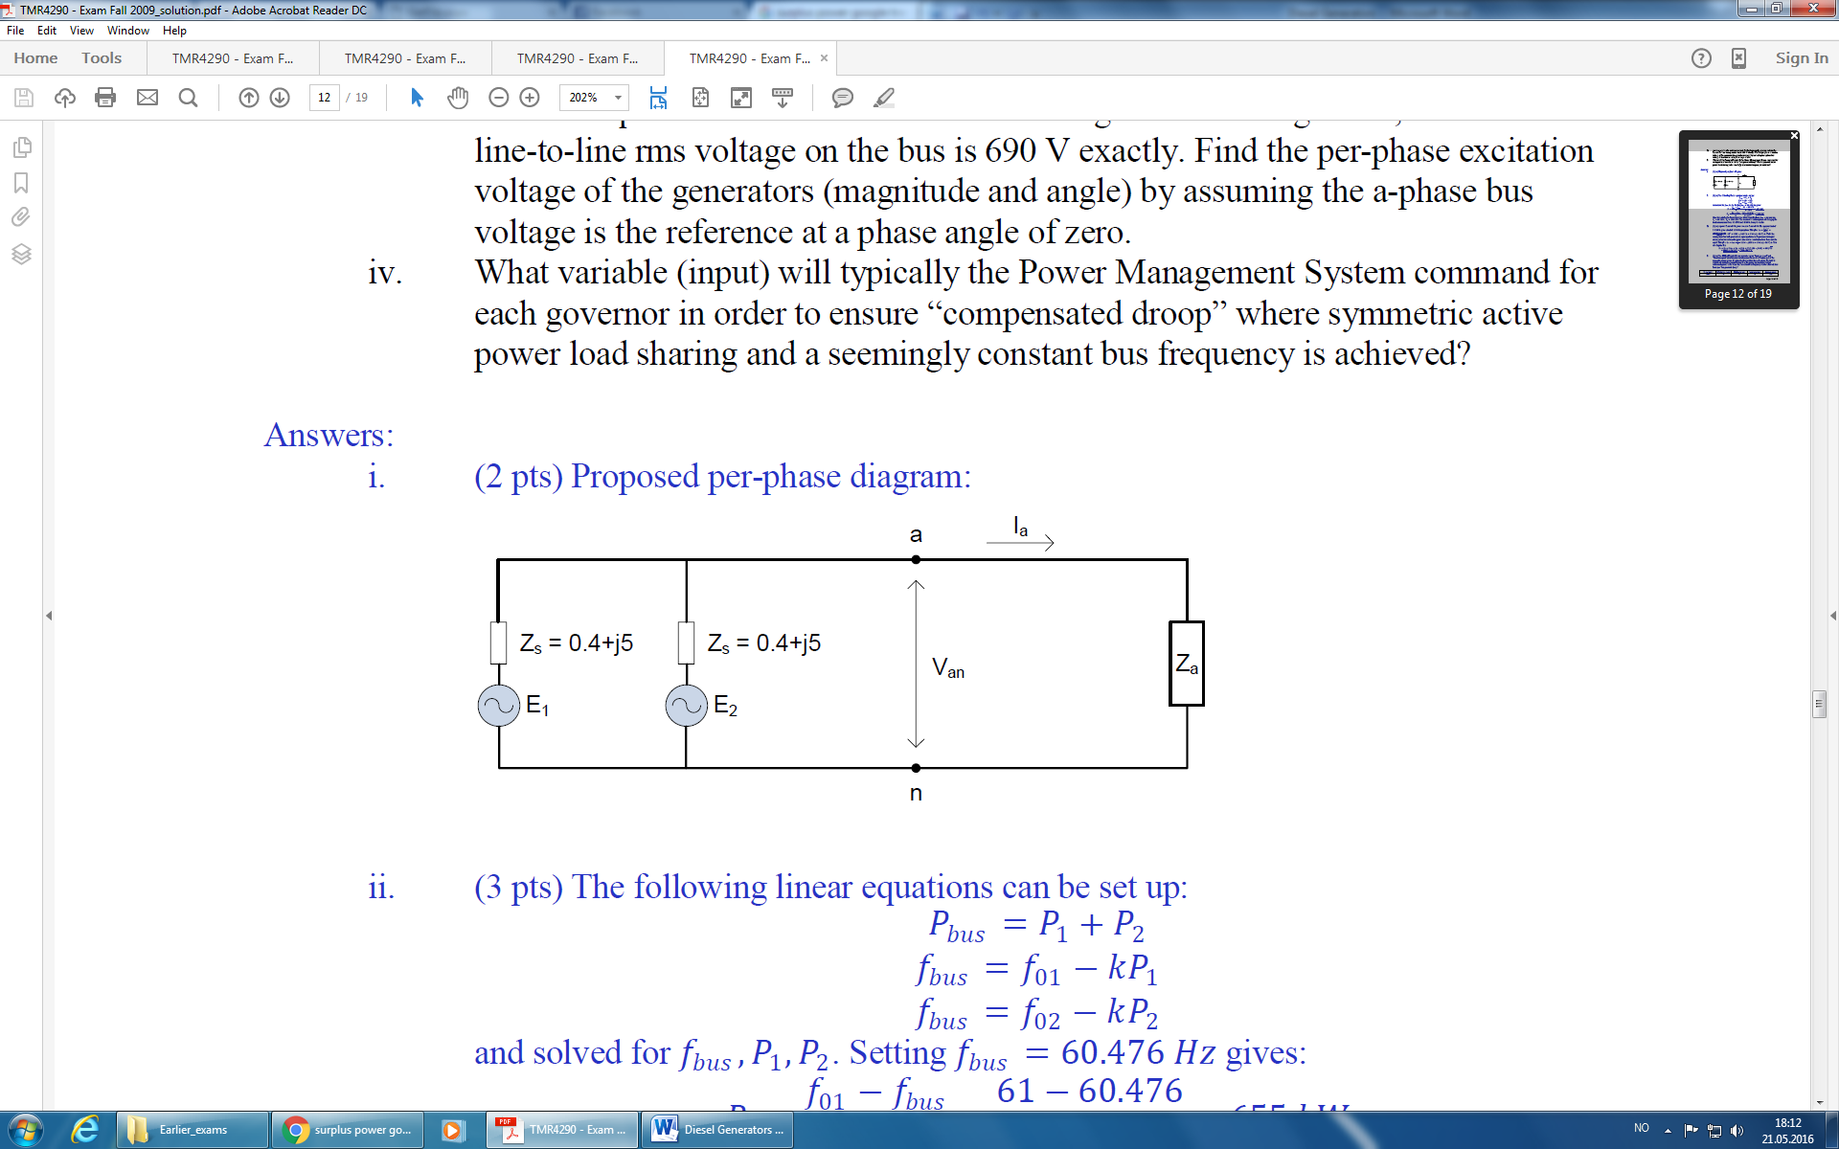

* 1. Let both gensets be connected in droop operation, with equal droop slopes 𝑘=8∙10−4 Hz/kW and non-equal no-load frequencies 𝑓01=61 𝐻z and 𝑓02=62 𝐻z. Set up 3 linear equations relating *P1*, *P2*, *Pbus*, *fbus*, and *f01*, *f02* where *P1*, *P2*, and *fbus* are unknown. If *fbus* = 60.476 Hz, what is the individual active powers *P1*, *P2* for the two gensets.

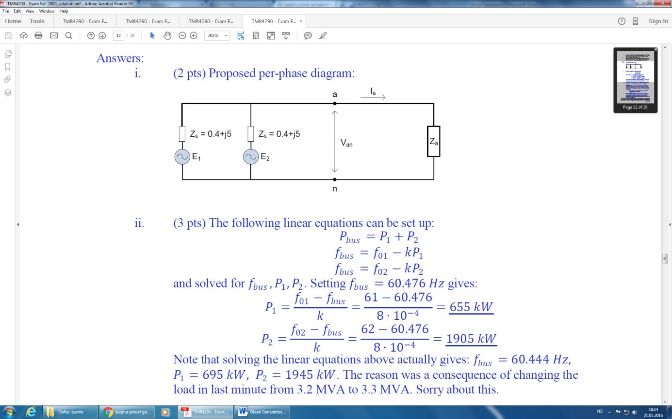

* 1. Assume equal active and reactive load sharing between the gensets, and that the line-to-line rms voltage on the bus is 690 V exactly. Find the per-phase excitation voltage of the generators (magnitude and angle) by assuming the a-phase bus voltage is the reference at a phase angle of zero.

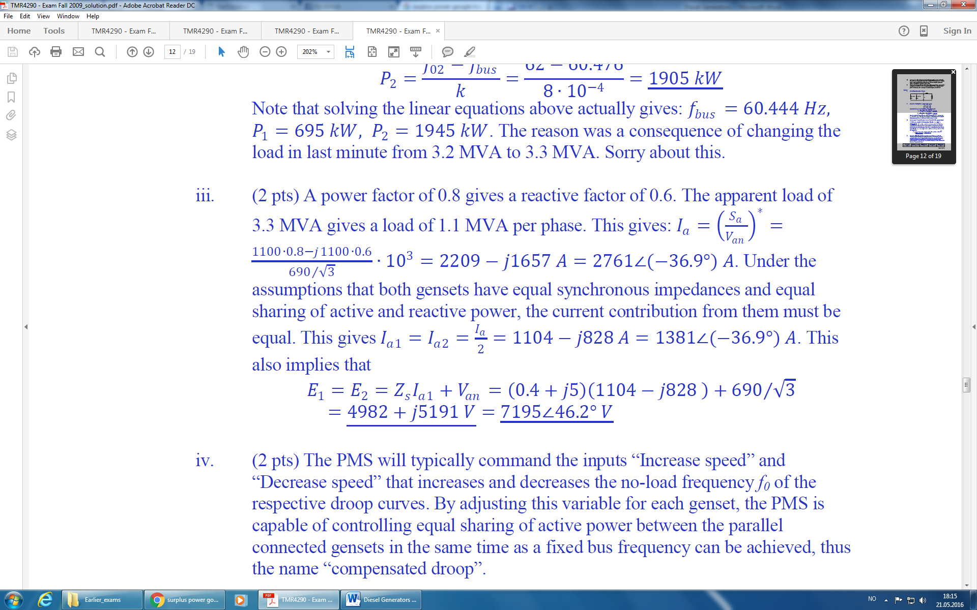

* 1. What variable (input) will typically the Power Management System command for each governor in order to ensure “compensated droop” where symmetric active power load sharing and a seemingly constant bus frequency is achieved?

**Answer:**

(2pts) The PMS will typically command the inputs “Increase speed” and “Decrease speed” that increases and decreases the no-load frequency f0 of the respective droop curves. By adjusting this variable for each genset, the PMS is capable of controlling equal sharing of active power between the parallel connected gensets in the same time as a fixed bus frequency can be achieved, thus the name “compensated droop”.

1. (3pts) Synchronization is the matching of waveforms between two AC electrical systems, e.g. a generator to be connected to a live power bus. What 5 conditions must be matched in order to achieve synchronization and be able to safely connect the two systems?

**Answer**:

* Numbers of phases in each system.
* Direction of rotation of phases (ABC or CBA)
* Voltage amplitudes of the two systems, typically within 1-5% limits.
* Voltage frequencies must match very accurately, typically within 0.2% bounds.
* Voltage phase shift must match, typically +/- 10 degrees.

**Diesel-generators (Droop & Isochronous Mode) Theory Exam 2010**

You have a diesel-electric system with three 3-phase, 60 Hz, Y-connected synchronous generators connected to a power bus. The 3 gensets are of equal type and size, with per-phase internal synchronous impedance Zs = jXs = j4 [Ohm]

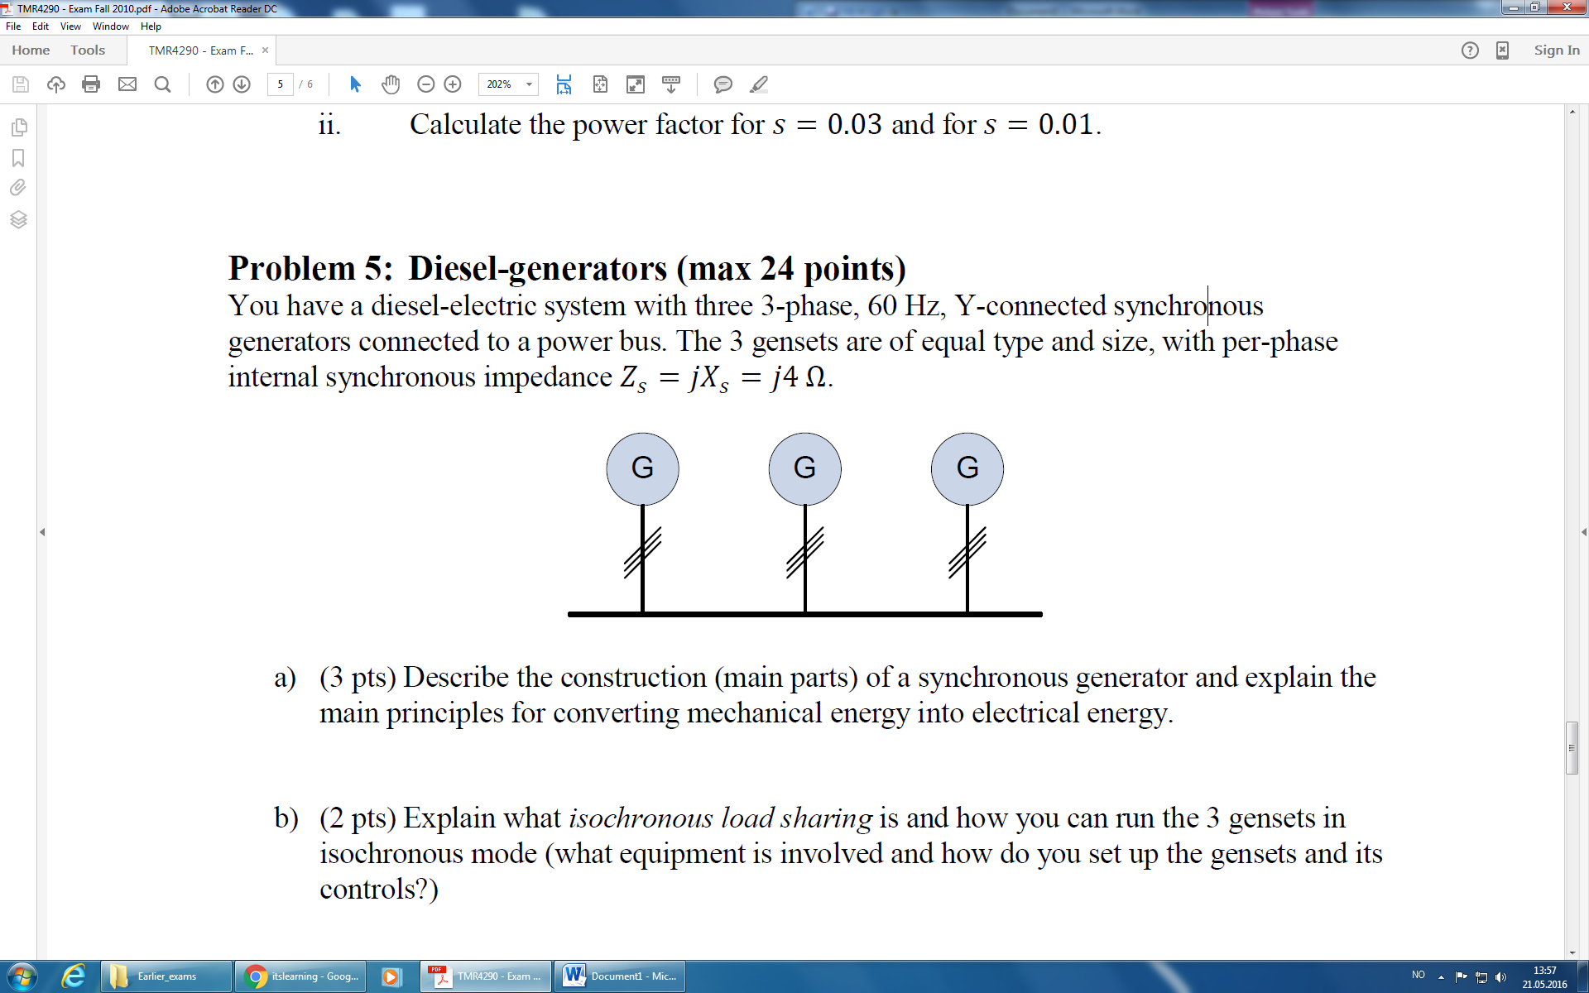

1. (2pts) Describe the construction (main parts) of a synchronous generator and explain the main principles for converting mechanical energy into electrical energy.

**Answer:**

A synchronous generator consists of stator and a rotor. In the stator there are 3-phase windings with p poles, while in the rotor there is a 3-phase winding that is powered by a DC field current through slip rings or through brushless arrangement. The DC field current is used to set up a constant magnetic field in the rotor. The shaft of the generator is driven by a prime mover, e.g. a diesel engine or a turbine. This results in the rotor magnetic field being rotated such that it by Faraday’s law induces a voltage in the stator windings. The speed of rotation is controlled by a governor such that the frequency of the induced voltage in the stator is according to the reference. Similarly, an Automatic Voltage Regulator controls the field current in the rotor that affects the size of the induced voltage and therefore the terminal voltage on the generator.

1. (2 pts) Explain what *isochronous load sharing* is and how you can run the 3 gensets in isochronous mode (what equipment is involved and how do you set up the gensets and its controls?)

**Answer:**

Isochronous load sharing is accomplished by having a load sharing line between the governors of all parallel connected gensets. This load sharing line provides a correction signal to the reference speed of each governor. The correction signal represents the average loading of each genset. The result is that all gensets will, in %, supply equal load to the power network while maintaining the system frequency at reference, e.g. 60 Hz. Each governor must be set to isochronous mode.

1. (6 pts) Let all 3 gensets in the system be connected to the bus, nominally delivering an equal amount of active power at a steady load. Suppose then that an active power load increase occurs on the bus (e.g. a large drilling motor was started):
   1. With all three gensets running in *isochronous mode*, what happens to the system frequency and the supplied active power by each genset?

**Answer:**

Frequency is kept constant, and the load increase is equally shared between the 3 gensets.

* 1. With all three gensets running in *droop mode* with equal droop settings, what happens to the system frequency and the supplied active power by each genset?

**Answer:**

All in Droop mode: The load increase results in a frequency drop according to the droop curve. The load is shared equally between the gensets.

* 1. With one genset running in *isochronous mode* and two gensets running in *droop mode* with equal droop settings, what happens to the system frequency and the supplied active power by each genset?

**Answer:**

Two in Droop mode: The load increase results in a frequency drop according to the droop curve. The load is shared equally between the gensets.

1. (1 pt) The power angle 𝛿 of a synchronous machine is the angle between the rotor magnetic field relative to the rotating magnetic field in the stator. If the power angle is negative, is then the synchronous machine supplying power (generating) or consuming power (motoring)?

**Answer:**

Negative power angle means that the synchronous machine is consuming power (motoring)

1. (2 pts) Draw the a-phase equivalent circuit for the 3 gensets connected to the electrical power bus, denoting the internally induced voltages 𝐸1,𝐸2,𝐸3, the terminal voltage (bus voltage) 𝑉𝑎𝑛, and the synchronous impedances 𝑍𝑠,1,𝑍𝑠,2,𝑍𝑠,3.

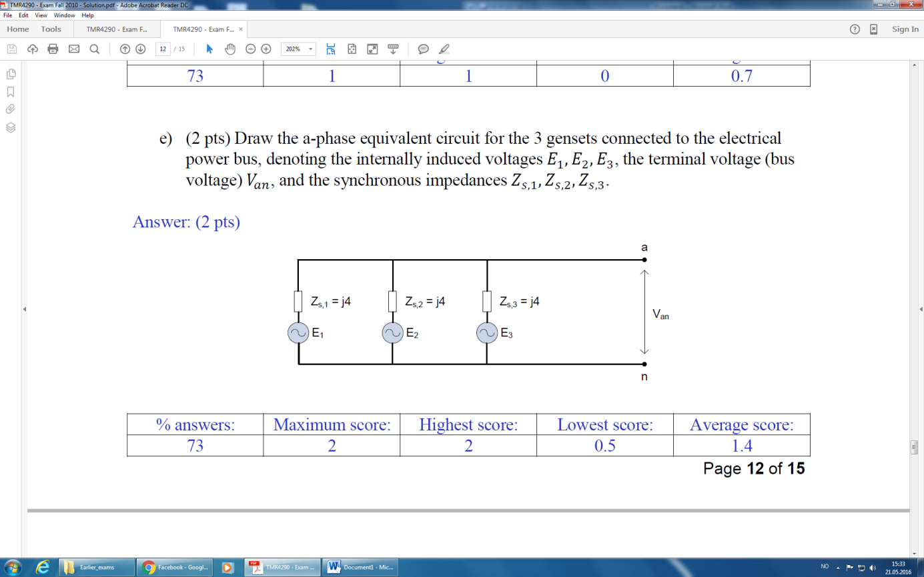**Answer:**

1. (6 pts) Let the line-to-neutral voltage be 𝑉𝑎𝑛=∠0° and for Genset 1, let the internally induced voltage be =∠ where and are the rms values and 𝛿1 is the power angle.
   1. Set up an expression of the complex power 𝑆1 for Genset 1, based on, , and 𝛿1. (Hint: Remember that 𝑗𝑋=𝑋𝑒^(𝑗𝜋/2)=𝑋∠90° and

𝑒^(𝑗𝜑)= cos𝜑 + 𝑗sin𝜑.)

**Answer:**

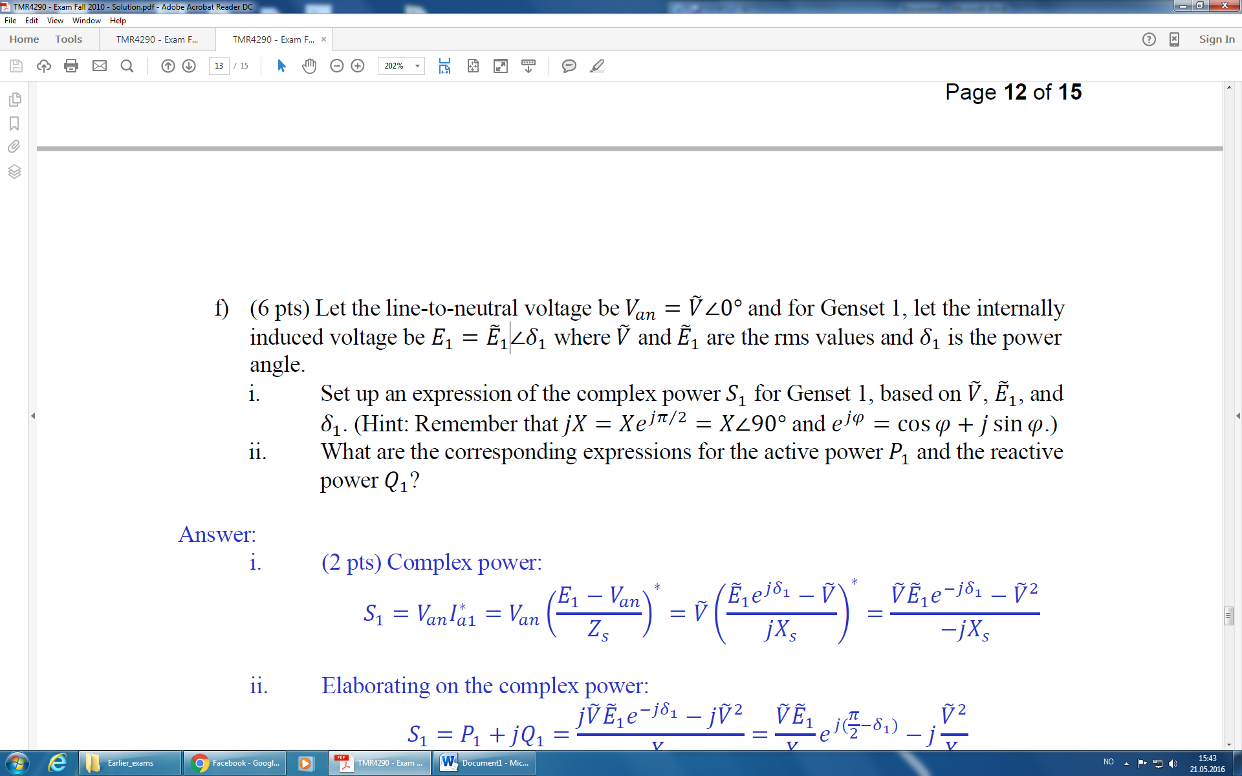

* 1. What are the corresponding expressions for the active power 𝑃1 and the reactive power 𝑄1?

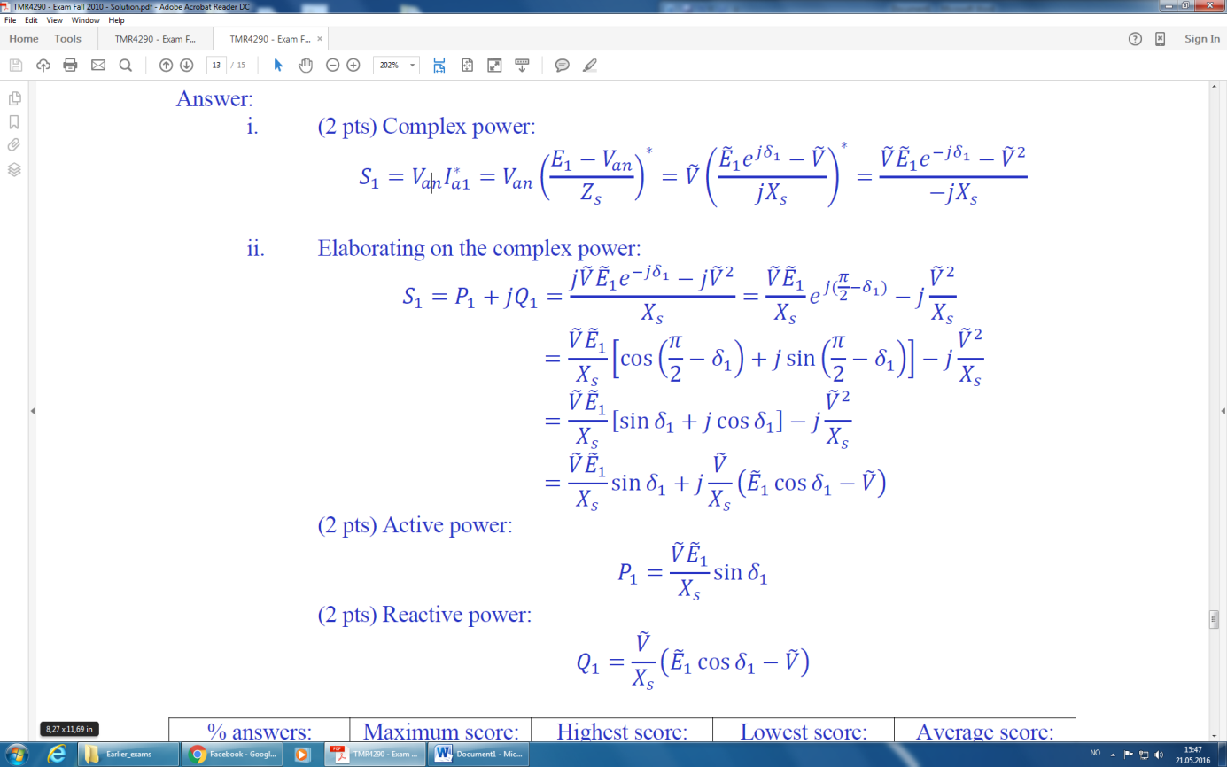 **Answer:**

1. (2 pts) What local control unit is used for the genset to manipulate the supplied active power to the bus when the genset is connected in parallel with other gensets on the bus? What other system variables does this local unit control?

**Answer:**

The speed controller, the governor, is used to control the speed of the engine by commanding the fuel input. By increasing the fuel index, the power angle of the genset will increase compared to the other parallel connected generators and the genset will then supply more active power.

1. (2 pts) What local control unit is used for the genset to manipulate the supplied reactive power to the bus when the genset is connected in parallel with other gensets on the bus? What other system variables does this local unit control?

**Answer:**

The voltage controller, the AVR, is used to control the induced voltage in the generator by commanding the field current to the rotor. By increasing the field current, the internal induced voltage in the generator will increase compared to the other parallel connected generators and the genset will then supply more reactive power. The AVR primarily controls the electric voltage amplitude on the generator terminals.